Case 6-Afr-Mali-Bozo or Sorko-Mermaid-Bronze-early 20th c
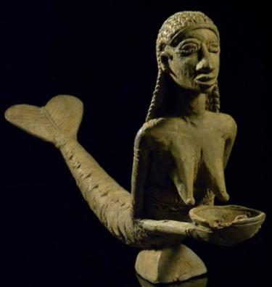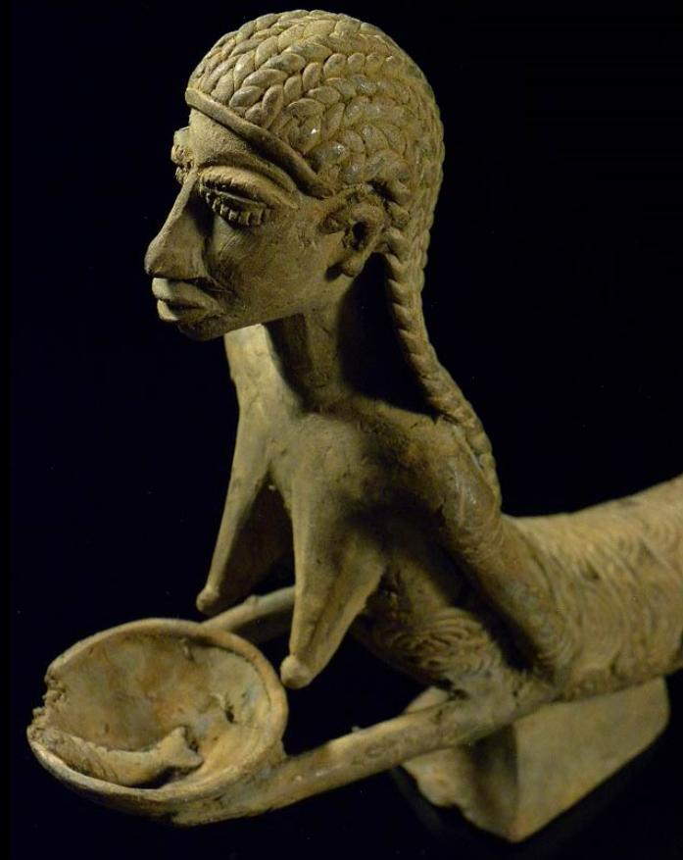
Semi-nude figure with fish tail probably made from a model from Sherbo, Sierra Leone but produced by the Bozo People along the Niger River in Mali by the lost wax process. Dimensions 18 x 37 cm.; Weight: 1.6 kg.; Material: Bronze.
The Sorko, Sorokawa (also Bozo) are a people of West Africa living mainly in the Niger valley and near the ponds. The Sorko are a component of the Songhai (Songye) people. Their alternative name, Bozo, is thought to derive from Bambara bo-so, 'Bamboo house'; the people accept it as referring to the whole of the ethnic group but they refer to themselves with more specific clan names such as Sorogoye, Hain, and Tieye. Sorko culture took shape under the 10th century Ghana Empire, when the Sorko took possession of the banks of the Niger and established the Malian cities of Djenné and Mopti.
The language of the Sorko belong to the Soninke-Bozo subgroup of Northwestern Mande languages with four distinct varieties: Xan Tie, Tiema and Sorogama (Kastenholz 1998; 2002:107-108)..

They are famous for their fishing and are occasionally referred to as the "masters of the river." The Sorko are also hunters of hippos and crocodiles. Their traditional religion is known as Holey.
This semi-nude figure with fish tail was probably made from a model from Sherbo, Sierra Leone, but was produced by the Bozo People along the Niger River in Mali by the lost wax process. This indigenous origin of the "mermaid" figure is summarized by Norman Fraser (1972: 278): "This three important canons of art-historical authenticity (degrees of centrality to the culture, agreement with local style, and duration as shown by the breadth of dispersal and functional differentiation) strongly indicate that the fish-legged figure in Nigeria predates the advent of the Portuguese in West Africa."
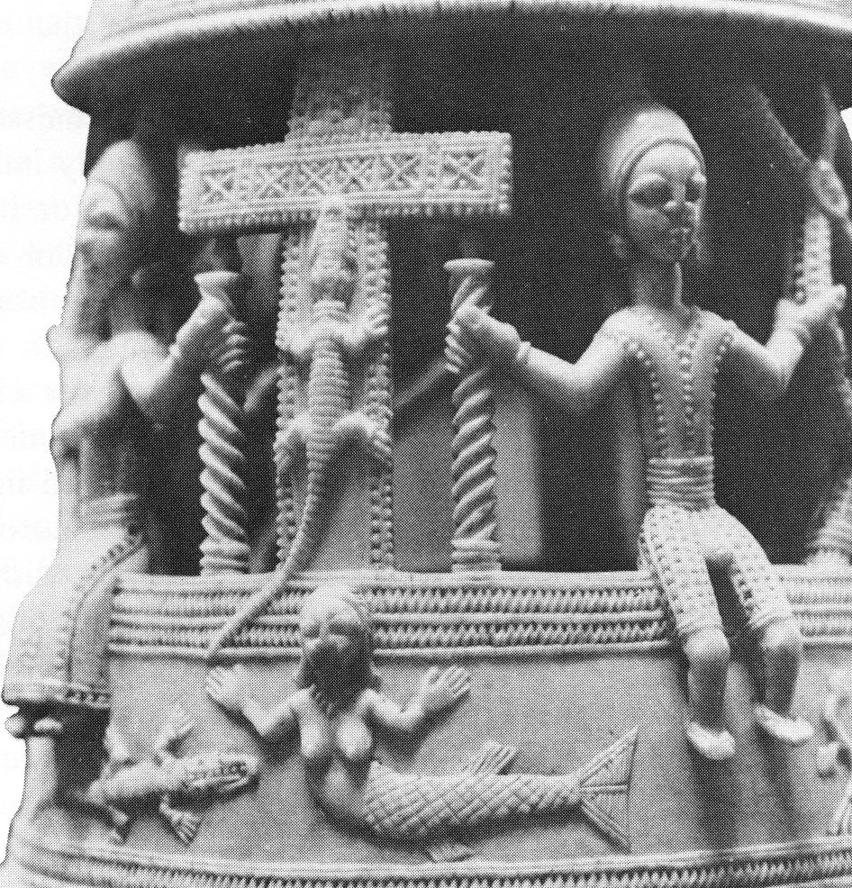
Sierra Leone, Sherbo, Afro-Portuguese ivory vessel known to have been in Denmark before 1743, National museum, copenhagen, edc 67) From Fraser 1972: 277.
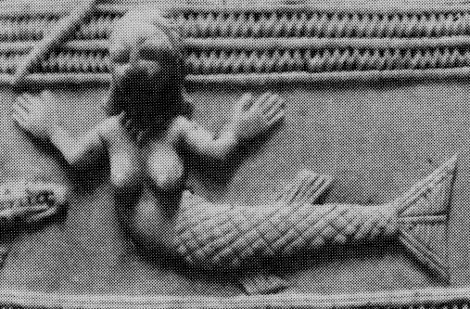
Detail from Fraser 1972: 277.

References
Fraser, Douglas. 1972. The Fish-legged Figure in Benin and Yoruba Art, in African Art and Leadership, edited by D. Fraser and H. M. Cole. Madison: University of Wisconsin Press.
Kastenholz, R. 1996. Sprachgeschichte im West-Mande. Methoden und Rekonstruktionen (Mande Languages and Linguistics 2). Cologne: Köppe.
Kastenholz, R. 2002. “Samogo” language islands and Mande-Senufo (Gur) interference phenomena, in R Nicolaï and P. Zima (eds.), Lexical and Structural Diffusion, Corpus, Les Cahiers 1: 91-109.
Ligers, Ziedonis. 1964-1969. Les Sorko (Bozo), maîtres du Niger: étude ethnographique. Paris: Librairie des Cinq Continents. 6 vols.

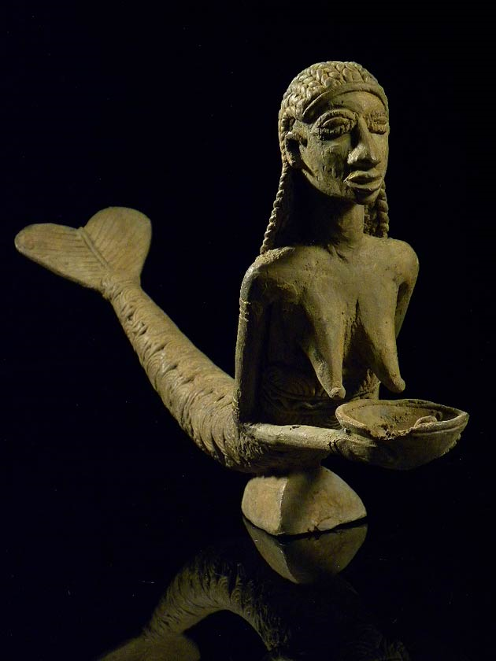Fraser, Douglas. 1972. "The Fish-legged Figure in Benin and Yoruba Art," in African Art and Leadership, edited by D. Fraser and H. M. Cole. Madison: University of Wisconsin Press.

